**Cell Respiration**

Cellular respiration is a series of **oxidative reactions** by which cells gradually release energy from glucose and transfer it to **ATP (adenosine triphosphate)**.

**Overall equation for aerobic respiration (one glucose molecule):**

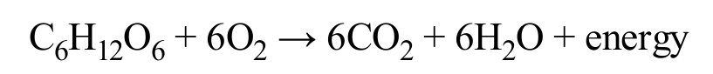

➡️ In words: **Glucose + Oxygen → Carbon dioxide + Water + Energy (ATP)**

**ATP — Adenosine Triphosphate**

ATP is a **high-energy molecule** that stores energy for immediate use in the cell.

* **Structure:**
  + Adenosine (**adenine + ribose**)
  + 3 phosphate groups

**ATP ⇄ ADP cycle:**

* When **one phosphate group is removed** from ATP → it becomes **ADP (adenosine diphosphate)**.
* This conversion **releases energy** for the cell to use.
* When a phosphate group is added back to ADP → ATP is formed again.
* This conversion **requires energy**.

**DR SALMA KHALED BIOLOGY EDUCATOR**

**Structure of the Mitochondrion**

* Mitochondria have **two membranes**:
  1. **Outer membrane**
  2. **Inner membrane (cristae membrane)** → folded to increase surface area.
* The inner membrane divides the mitochondrion into two compartments:
  1. **Outer compartment**
  2. **Matrix**

**Where reactions happen:**

* **Krebs cycle** → in the **matrix**
* **Electron transport chain (ETC)** → in the **cristae membrane**

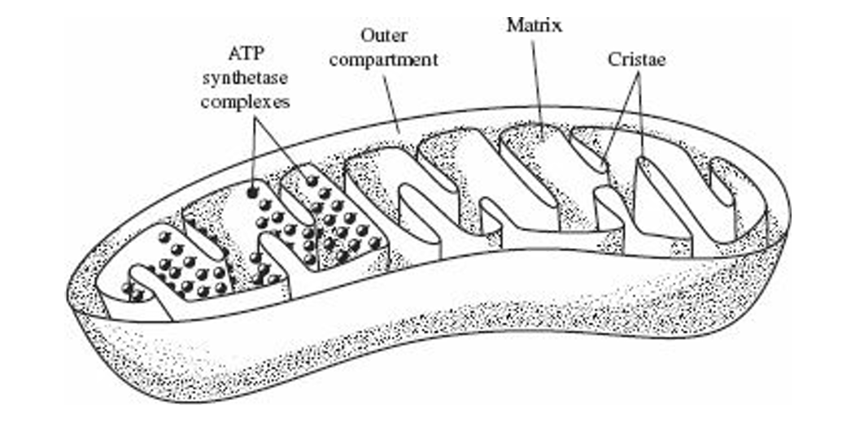

**DR SALMA KHALED BIOLOGY EDUCATOR**

**Anaerobic Respiration (No Oxygen)**

* **Definition:** Anaerobic respiration (fermentation) = **Glycolysis** + either:
  + **Alcohol fermentation**
  + **Lactic acid fermentation**

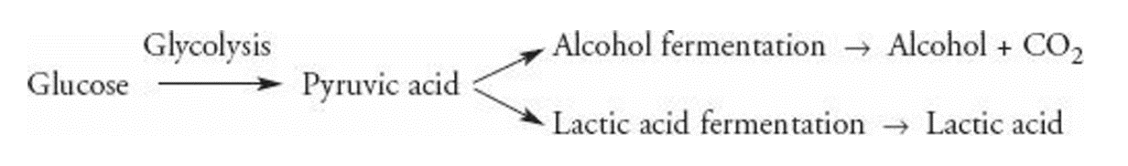

**Alcohol Fermentation**

* **Definition:** Pyruvate (from glycolysis) → **Ethyl alcohol + CO₂** (no oxygen).
* **Where it happens:** Yeast & some bacteria.
* **Uses:**
  + Bread-making → CO₂ makes bread rise.
  + Beer, wine, liquor industries → sugar fermented into alcohol.

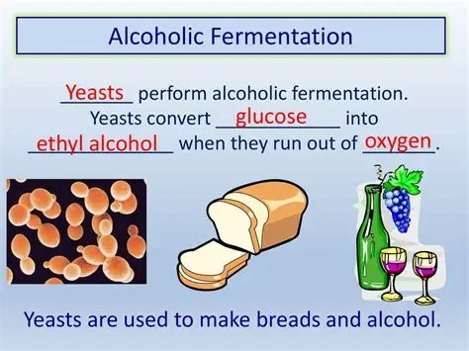

**DR SALMA KHALED BIOLOGY EDUCATOR**

**Lactic Acid Fermentation**

* **Definition:** Pyruvate → **Lactic acid** (when O₂ is insufficient).
* **Where it happens:** Skeletal muscles during **strenuous exercise**.
* **Effect:**
  + Lactic acid builds up → **muscle fatigue & burning pain**.
* **After exercise:**
  + Blood brings more oxygen → muscles switch back to **aerobic respiration**.
  + Lactic acid is carried to the **liver**, converted back into pyruvate.

**Aerobic Respiration (with O₂ present)**

➡ Consists of **3 main processes**:

1. **Glycolysis** (anaerobic step, happens first)
2. **Krebs Cycle (Citric Acid Cycle)**
3. **Electron Transport Chain (ETC) + Chemiosmosis**

## **1. Glycolysis**

* Location: **Cytoplasm**
* One glucose → **2 pyruvate**
* Energy input: **2 ATP**
* Energy output: **4 ATP** → **Net = 2 ATP**
* Produces: **2 NADH**
* Equation:  
  **Glucose + 2 ATP → 2 Pyruvate + 4 ATP + 2 NADH**

**DR SALMA KHALED BIOLOGY EDUCATOR**

**2. Krebs Cycle (Citric Acid Cycle)**

* Location: **Mitochondrial Matrix**
* Pyruvate + Coenzyme A → **Acetyl-CoA** (enters cycle)
* Each turn produces:
  + **1 ATP**
  + **3 NADH**
  + **1 FADH₂**
  + **CO₂ (waste, exhaled)**
* Main role: produces **high-energy carriers (NADH, FADH₂)**

## **3. NADH & FADH₂**

* Function: **Shuttle electrons & protons** from glycolysis and Krebs to ETC.
* Forms:
  + NAD⁺ (oxidized) → NADH (reduced)
  + FAD⁺ (oxidized) → FADH₂ (reduced)
* Remember:  
  **NADH & FADH₂ = "energy buses" carrying H⁺ & e⁻ to ETC**

## **ATP Yield (approximate)**

* From NADH → **3 ATP each**
* From FADH₂ → **2 ATP each**
* **Most ATP comes from ETC + Chemiosmosis**

**DR SALMA KHALED BIOLOGY EDUCATOR**

**4. Electron Transport Chain (ETC) + Chemiosmosis**

* Location: **Cristae (inner mitochondrial membrane)**
* **ETC process:**
  + NADH & FADH₂ deliver electrons → electrons passed along carriers (cytochromes).
  + Energy pumps **protons (H⁺)** across cristae → **proton gradient** (potential energy).
* **Chemiosmosis (Oxidative phosphorylation):**
  + Protons flow back through **ATP synthase** (like a turbine).
  + ATP synthase adds phosphate → ADP → **ATP**.
* **Oxygen role:**
  + Final electron acceptor → combines with H⁺ & e⁻ → forms **H₂O (waste, exhaled water vapor)**.

**DR SALMA KHALED BIOLOGY EDUCATOR**

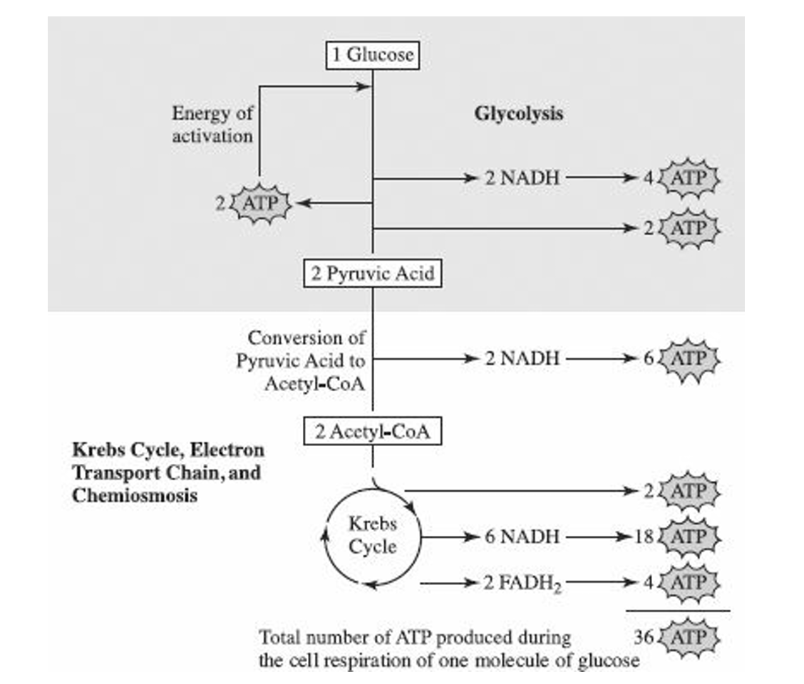

**DR SALMA KHALED BIOLOGY EDUCATOR**